https://www.mdpi.com/2076-3417/11/1/68#Ground_Microgravity_Simulators
This paper states :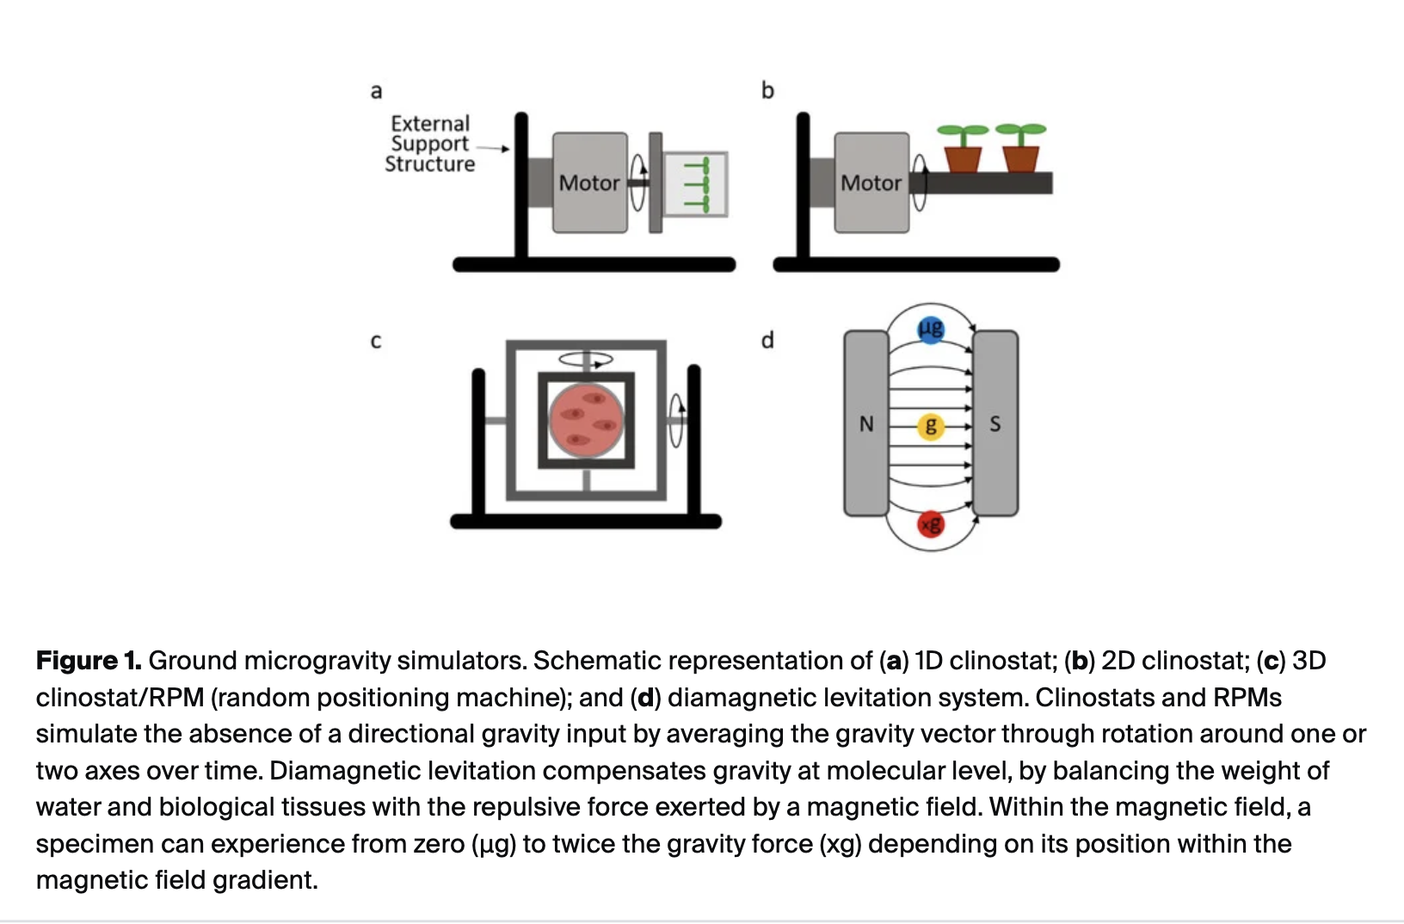

2)
https://www.frontiersin.org/journals/space-technologies/articles/10.3389/frspt.2022.1032610/full
Refer this for data and code
https://www.nature.com/articles/s41526-026-00570-8
Refer this while writing
First, taSMG should converge to a microgravity level within a limited time frame.
Second, the distribution of the gravity vector should be uniform.
Third, randomness should be incorporated so that the gravity vector follows a different trajectory in each trial.

